Mixed Media Visual Journal Assignment #2 Due 10/06
~Create another set of 10 double pages spreads combing 3-5 media. Try using only circles for one, Try using only
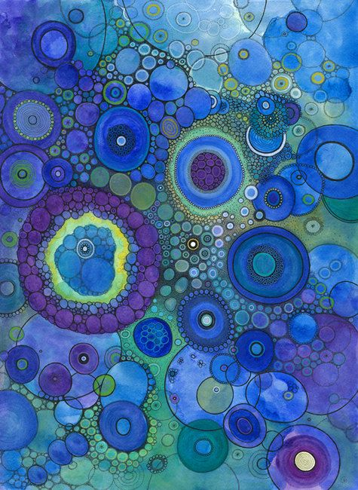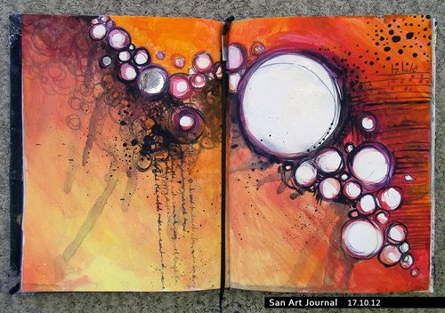
~Create a double page spread. Use 3-5 different medias. Spend 1 hour on this entry visually and verbally responding to ……..How do you feed your spirit?
Without proper nourishment, our body grows weak, and we must feed ourselves to maintain our physical health. Our spirit needs nourishment as well, but dealing with the world can run us down, exhaust us, and put our spiritual health and mental well-being in jeopardy. We all have a different way of feeding our spirit. For some, it is a certain place that rejuvenates and refreshes us. Maybe it’s hiking in the woods, paddling out into a set of double overhead waves, or spending time at an art retreat. But it doesn’t have to be a place at all. Perhaps it’s the people who surround us, the daily phone call or e-mail, or the sharing of the ride to work that provides these spirit-feeding moments. It may be our routines and daily rituals that feed our spirit in small, meaningful ways. Possibly it’s the morning cup of coffee, the daily crossword, or the comfy sweatshirt that gives us the lift we desire. Whatever the source, experience and recognize the connections you need in order to fill up your tanks and keep yourself going.
What people, places or things have the power to recharge your batteries? What daily rituals and routines energize you, fill you with purpose and allow you to tackle another day?

