The VISUAL JOURNAL

- The most famous sketchbooks are those of Leonardo da Vinci. His sketchbooks are filled with drawings, diagrams and written notes of things he saw and ideas he came up with.

- Picasso produced 178 sketchbooks in his lifetime! He often used his sketchbooks to explore ideas and make compositional studies until he found the right idea or subject for a larger painting.

- Frida Kahlo created a visual diary of amazing illustrated journal documents. It is of her thoughts, dreams, poetry and illustrations. …. It is in this room, check it out!

- I did not realize until I was in college that sketchbooks are for more than just drawings! They can be a journal…a diary of my thought process – I can refer back to for more ideas later. I used to just draw in sketchbooks, NOW: I draw, paint, write, collage, and attach anything that gives me an idea or expresses who I am as an artist and person! Pictures, photos, poems, lyrics, etc…

SKETCHBOOK/Visual Journal GUIDELINES (how you will be graded)
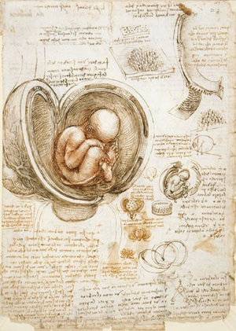
√+’s = excellent, went over and above, successful
√-’s = lacking, could have put more effort and thought into work
√’s = did what you were asked, tried something new, good work, could use some verve with design
0 = no work, not completed, absent and showed no work when returned

  - Late work is not acceptable, you grade will reflect it.
- Missing assignments will be recorded as zeros, don’t go there! Remember, we are developing Artistic Habits of Practice.
- Title the VISUAL JOURNAL PROMPT. It must be a double-page spread.
- FILL THE PAGE! Each composition should touch the edges of your paper.
- 3D objects are allowed – even encouraged – think about a relief, collage, etc…
- Unless otherwise noted, ALWAYS include a wide range of values (even in color work)!
- Always think about BALANCE and where is the EMPHASIS? What should we focus on as a viewer?
- Spend AT LEAST 30 minutes to 1 hour PER PROMPT. It is called artwork for a reason;

  - Drawings from observation are preferred – meaning you should LOOK at the object(s) while you are drawing them…try NOT to draw from memory.
  - You can work on these in class when waiting on a new assignment or completed your work.

I want your sketchbook to be a storehouse FULL of pages to trigger your creativity and ideas!
You can mess up as much as you want as long as you fill the page and try again.

Directions: Using the list below prepare pages in your visual journal using your own individual flare. You will be graded on the completed steps, your inventiveness, and craftsmanship. Each page can now be “used” and hopefully the white page syndrome of the “sketchbook/visual journal will fall by the wayside.

Remember you are not creating finished works, but creating interesting surfaces to draw onto later.
1. Create a two-color wash on the page.
2. Collage text on the page and wash over the page to subdue the texture.
3. Scribble on the page with pencil; blend with a paper towel to create a value.
4. Create a one color wash on the page.
5. Cut squares in the page.
6. Draw a childlike drawing on the page and paint over it.
7. Create a repetitive pattern on the page using a geometric shape.
8. Find a simple object and cover the page with simple contour drawings of it.
9. Using muted colors paint a page.
10. Create a texture on the page with paint by lifting paint with a towel.
11. Create a negative space painting with a wash.
12. Cover the page with writing about your first day and summer.
13. Collage random pieces on the page.
14. Cut strips of colored paper and glue to the surface.
15. Doodle on the page with a pen.
16. Trade books and have another student treat the surface of a page
17. Tear a page out and re-collage onto another page.
18. Find a leaf outside. Represent the leaf in some way on the page.
19. Other media exploration.
20. Prep 5 other pages any way that you would like.

Remember that the pages should not be overwhelming. Be neat, use good craftsmanship, and beware of pages sticking together. FINALLY...A visual journal Is A Journey, Not A Destination!!!

Visual Journal Entry #1

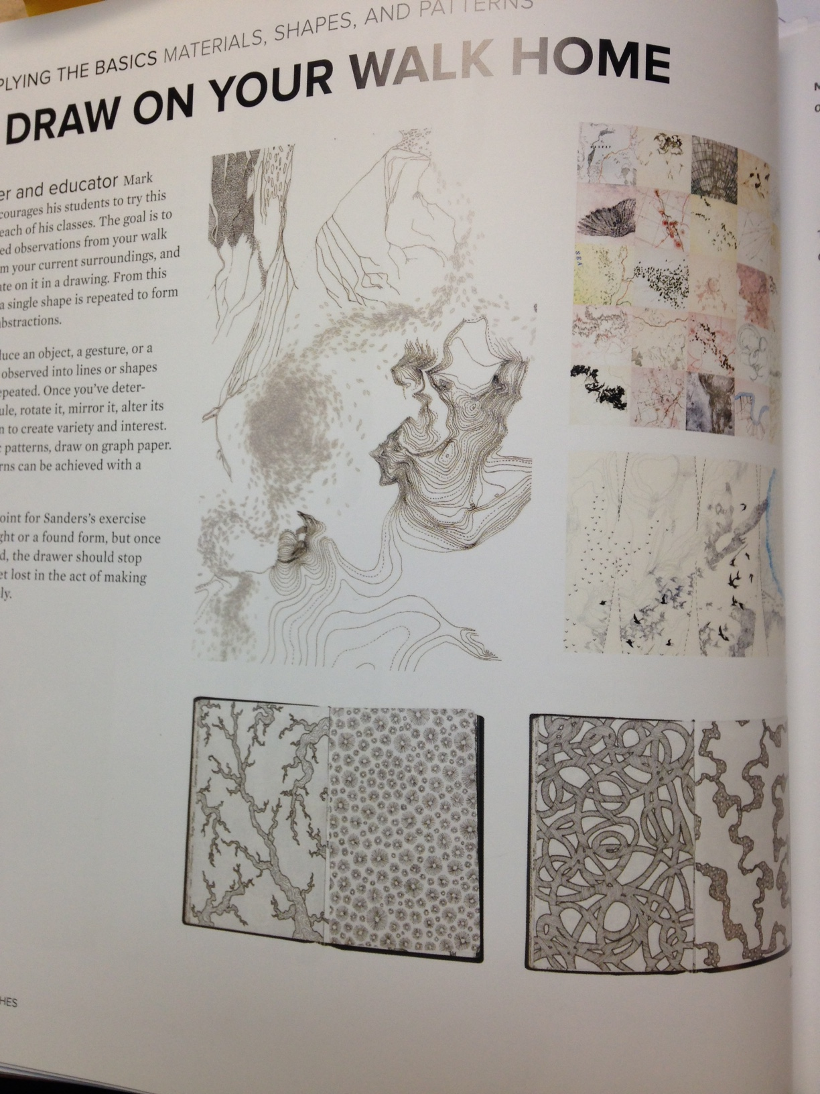
A day Due: September 14
B day Due: September 13
- Create 10 double-page spread backgrounds
- Draw your HANDS 3X & FEET 3X
- Draw your walk home: The goal is to make detailed observations from your walk home or from your surroundings, and then elaborate on it in a drawing. (2-page spread)
  - Start by making/drawing a map of your walk home/surroundings (2-page spread)
  - Second reduce an object, a gesture of a detail you’ve observed not lines or shapes that can be repeated. Once you have determined a module, rotate it, mirror it, alter its size, and so on to create variety and interest. (2-page spread)

Sketchbook Prompts

#1 Due: Friday, August 16 Negative space studies (9)

#2 Due: Friday, August 23 Fingerprints

#3 Due: Friday, Aug 30 Direct Observational work – look at something and draw it!

#4 Due: Friday, Sept. 6 Today I feel…

#5 Due: Friday, Sept. 13 Rubbings of textures.

#6 Due: Friday, Sept. 20 Grateful for…

#7 Due: Friday, Sept. 27 Contour Art Work

#8 Due: Friday, October 4 An Adventure

#9 Due: Friday, October 11 A Dream

#10 Due: Friday, October 25 A ticket to…

These 5 entries will be for the 2nd Sketchbook project grade …1 missing will hurt your grade!

#11 Due: Friday, Nov 1 It’s almost…

#12 Due: Friday, Nov 8 You can see or hear…

#13 Due: Friday, Nov. 15 Imagine yourself…

#14 Due: Friday, Nov 22 I am…!

#15 Due: Friday, Dec 6 YUM, this recipe…

